**PROJECT OF HTML**

Creating a Basic HTML Webpage with Image and External Link

**📋 Project Steps:**

**Step 1: Create a Project Folder**

* Go to the **Desktop** and create a folder named html.
* This folder will store all your project files (HTML and images).

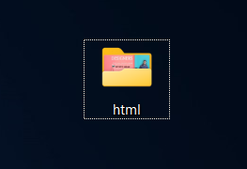

**Step 2: Add an Image to the Folder**

* Save an image inside the html folder.
* Make sure the image file name is simple (e.g., photo.jpg or image.png) and has no spaces.

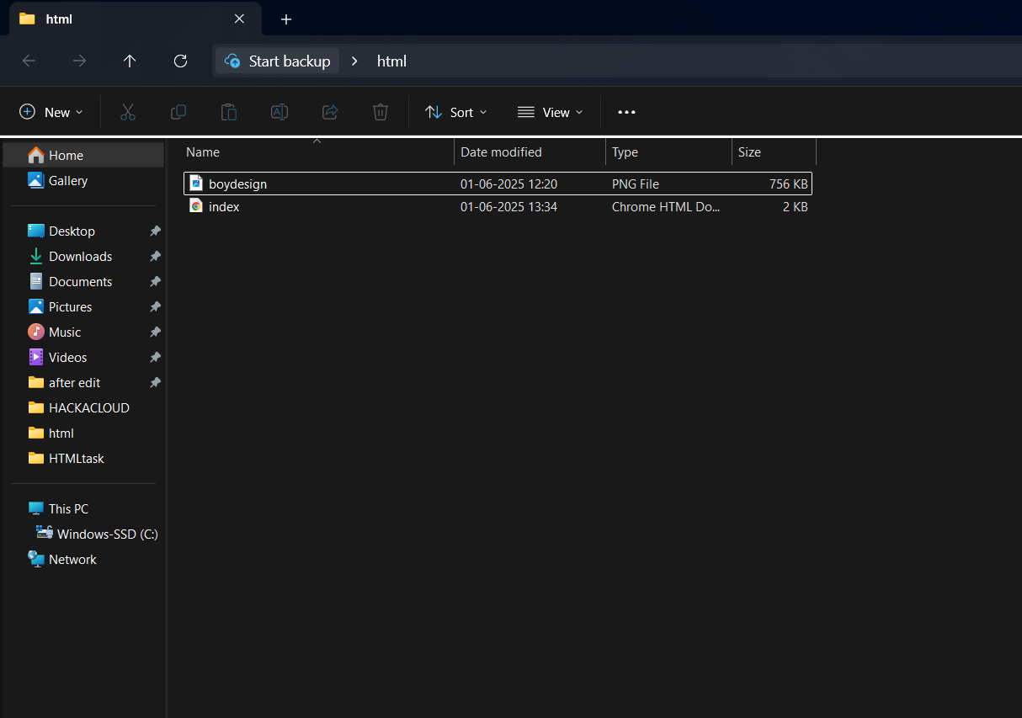

**Step 3: Create an HTML File**

* Inside the html folder, create a file named index.html.



**Step 4: Write HTML Code**

* Open index.html in a code editor (like Notepad, VS Code, or Sublime Text).
* Write HTML code to:
  + Display the image using the <img> tag.
  + Add a clickable link using the <a> tag that redirects to the **Myntra** website.

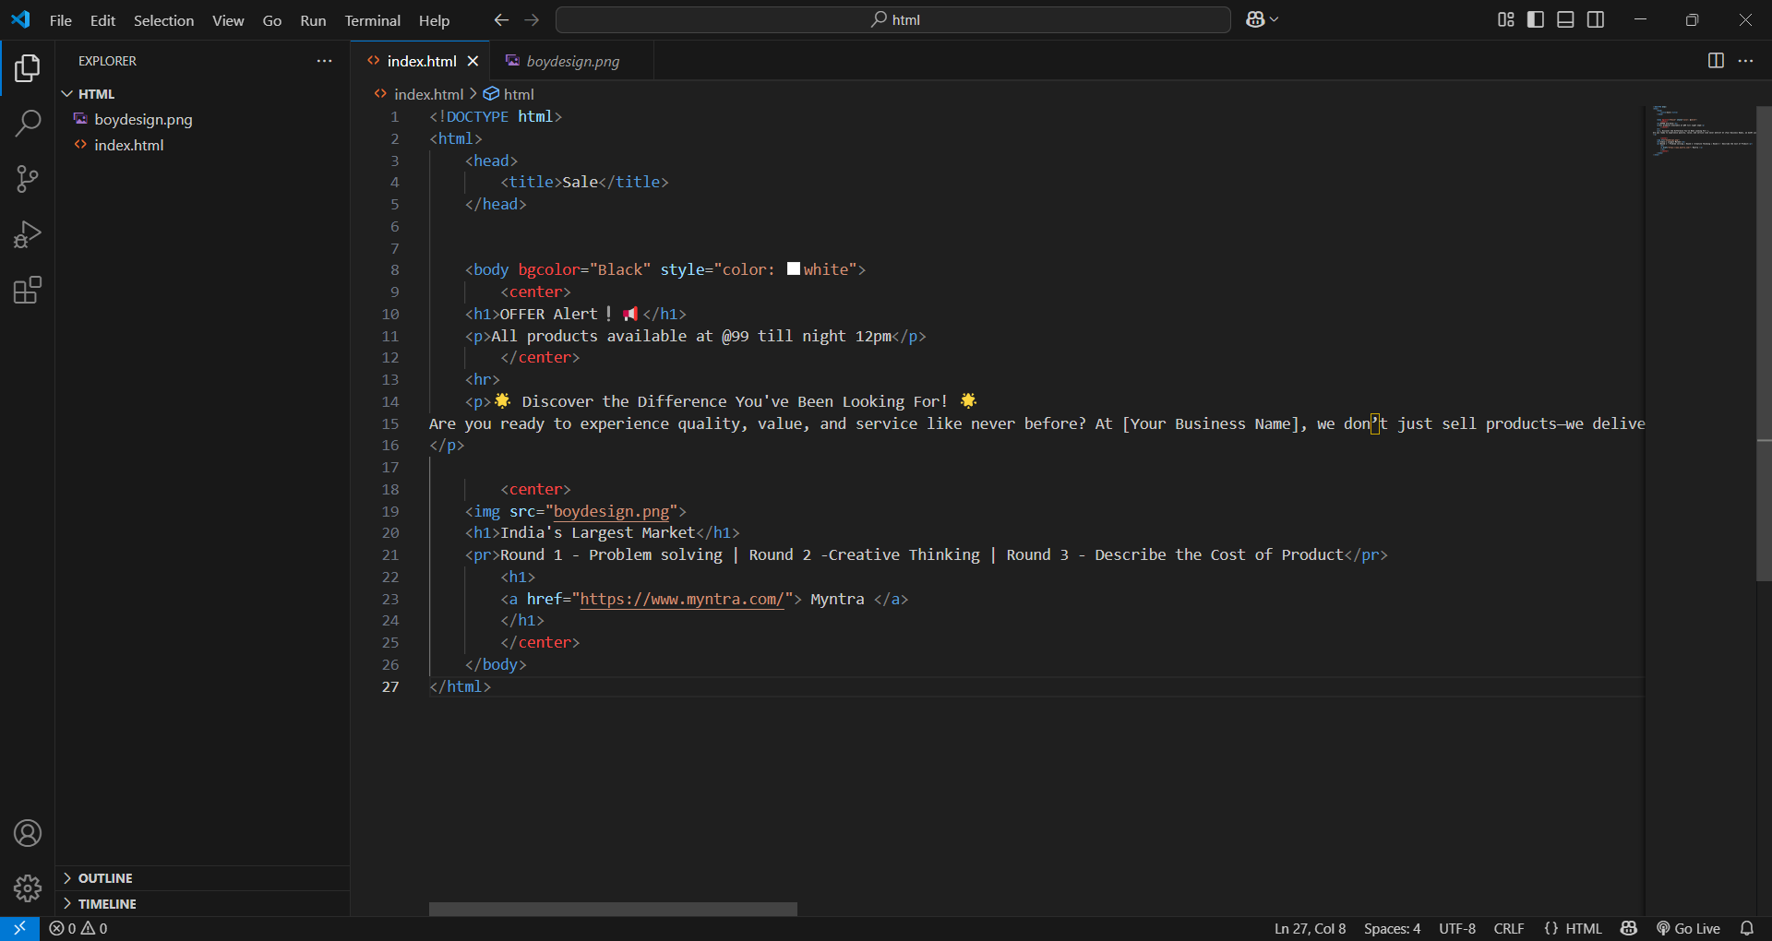

**Step 5: Run the HTML File in a Browser**

* Double-click index.html or right-click and open it with a web browser.
* The page should:
  + Show the image.
  + Display a link named **"Visit Myntra"** under the image.
  + When clicked, the link should open the **Myntra** website in a new tab.



**Project Output:**

* A basic webpage with an image and a working hyperlink.

